Institution name: | Bangladesh Institute of Management Studies (BiMS)
Logo: | 
Location: | Dhaka, Bangladesh
Category: | - Training & Education Provider
Scope: | - Project Management  - Human Resource  - Marketing  - Supply Chain  - Business Administration
Website: | www.bimsedu.com

🎥 Success stories page cover:
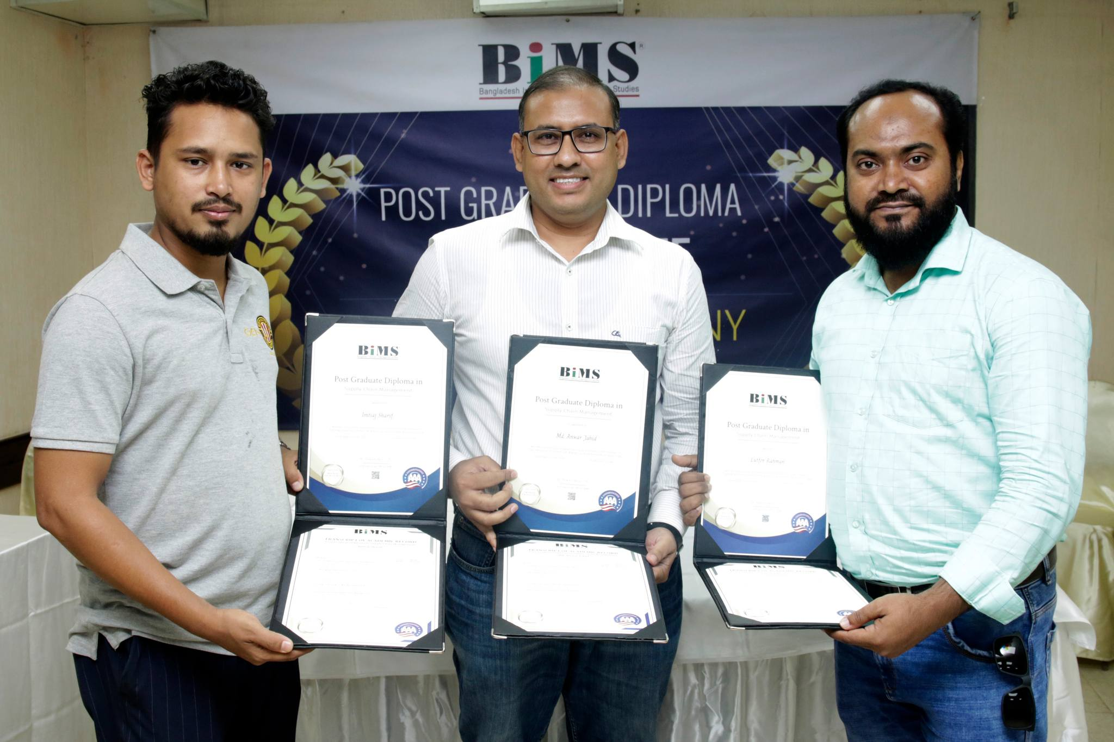

How AAA Accreditation Elevated BiMS as a Leader in Management Education

Who Is BiMS?
BiMS (Bangladesh Institute of Management Studies) is a pioneering institution in management education, dedicated to delivering affordable, internationally accredited programs to professionals across Bangladesh and beyond. Since its inception in 2004, BiMS has been at the forefront of industry-aligned education, offering Post Graduate Diploma (PGD) programs in:
- Human Resource Management (PGDHRM)
- Supply Chain Management (PGDSCM)
- Project Management (PGDPM)
- Marketing & Brand Management (PGDMBM)
With a commitment to flexibility and accessibility, BiMS combines live online classes and pre-recorded lectures, ensuring learners can balance education with professional demands.
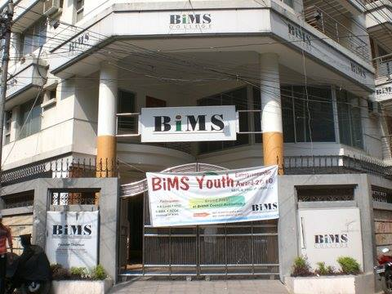

Why Did BiMS Seek AAA Accreditation?
To validate its commitment to global education standards, BiMS pursued accreditation from the American Association for Accreditation (AAA). This move was strategic—enhancing credibility, attracting international recognition, and ensuring graduates remain competitive in the global job market.
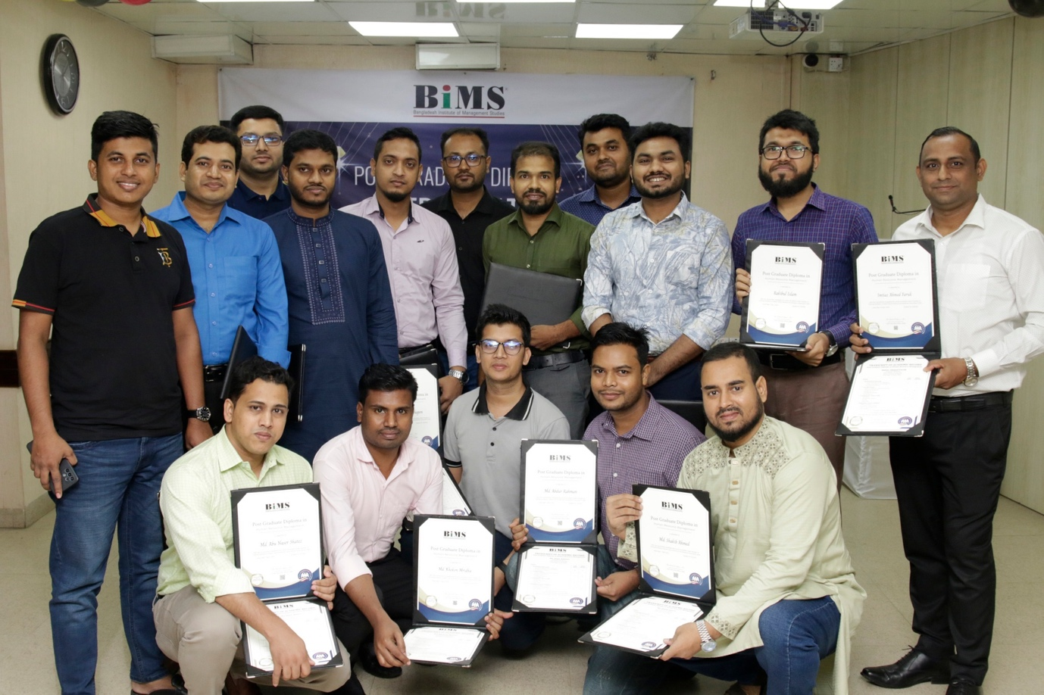

The Challenge: Standing Out in a Competitive Education Landscape
Before AAA accreditation, BiMS faced key challenges:
- Lack of formal international recognition – Without a globally recognized accreditation, professionals were hesitant to enroll.
- Need for structured quality assurance – They wanted to align their curriculum with global best practices.
- Competitive differentiation – The management education sector is crowded, and BiMS needed a way to prove its excellence.

The Solution: AAA Accreditation as a Trust Mark
The accreditation process was rigorous but transformative, requiring BiMS to:
✅ Strengthen curriculum alignment with international standards.
✅ Enhance documentation and compliance to meet AAA’s benchmarks.
✅ Improve faculty training and assessment methods for better learning outcomes.
"The process was thorough and insightful, reinforcing our quality practices. We addressed challenges related to aligning documentation with AAA’s specific standards."
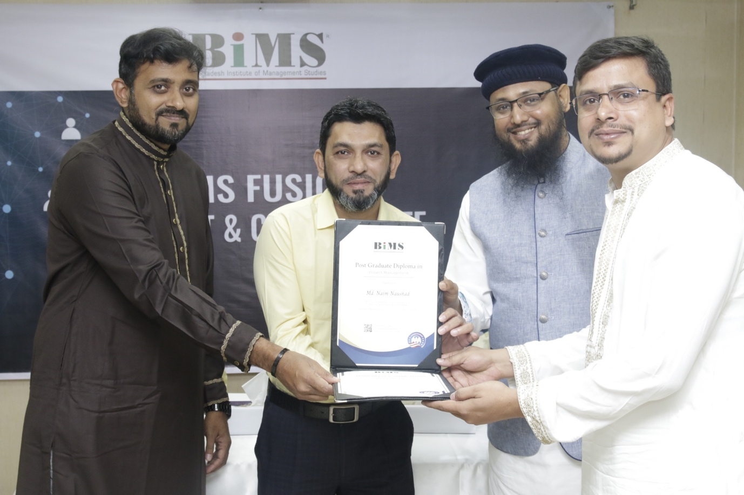

The Results: Growth, Credibility, and New Opportunities

📈 Key Metrics Post-Accreditation
Impact Area | Before AAA | After AAA | Growth/Improvement
Student Enrollment | Baseline | +5% | Steady increase
Certificates Issued | N/A | 500+ | AAA-recognized certs
New Partnerships | Limited | Expanded | More discussions with global institutions

✅ Tangible Benefits
✔ Enhanced Reputation – Students and employers now trust BiMS certifications as globally recognized.
✔ Increased Enrollment – A 5% rise in student numbers post-accreditation.
✔ New Market Opportunities – Discussions with international partners have expanded.
"The accreditation has bolstered our reputation, assuring stakeholders of our adherence to high-quality education standards."
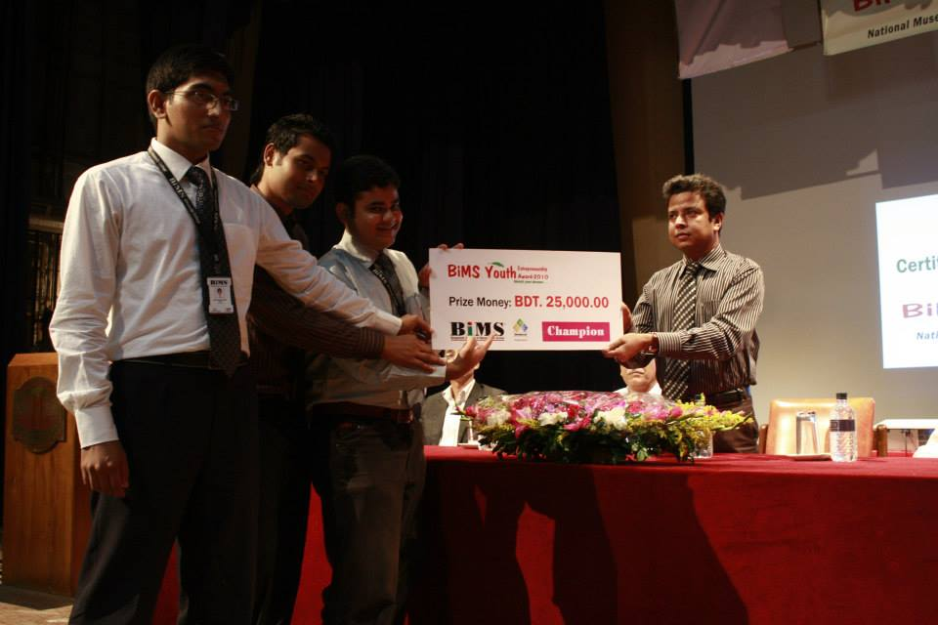

Future Goals: Expanding Global Reach
BiMS aims to:
🌍 Launch new programs with international collaborations.
📊 Increase student engagement through interactive learning.
🎯 Leverage AAA accreditation to attract more corporate training partnerships.
"Our future objectives include expanding our programme offerings and establishing international collaborations to further elevate the quality of education we provide."
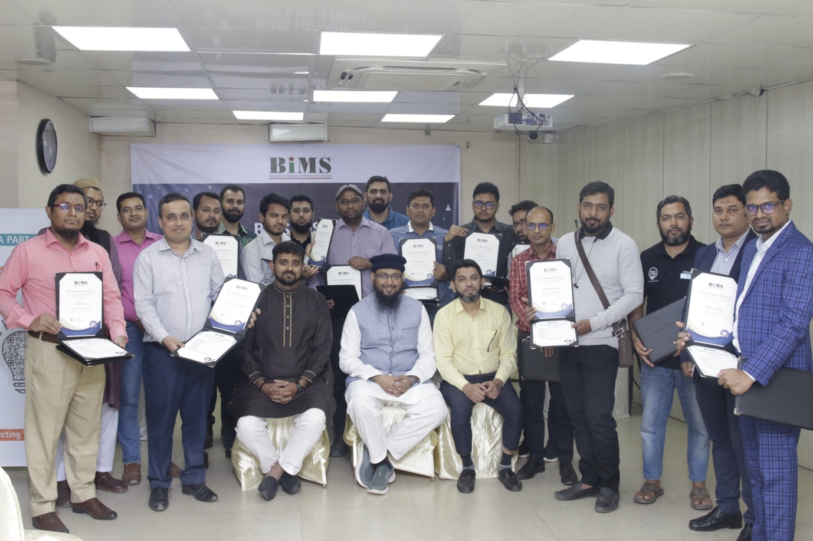

🔹 In Their Words
“Being accredited by AAA isn’t just a badge—it’s a continuous commitment. It has made our students prouder, our instructors more focused, and our institution more forward-looking.”
— Md. Mahbubul Hassan Mim, CEO & Head of Operations


Conclusion: A Strategic Leap Forward
AAA accreditation has been a game-changer for BiMS, reinforcing its position as a leader in management education. By meeting global standards, BiMS has not only gained credibility but also unlocked new growth avenues—proving that quality education opens doors worldwide.
